Linux Task Documentation – User, Group & File Permissions

Date: 9 February 2026
Objective:
The objective of this task was to understand and practice Linux user management, group management, file creation, and permission handling using terminal commands.

Environment:
- OS: Linux (Ubuntu / WSL)
- Terminal: Bash
- Users: shariqua, elon

Tasks Performed:
- Created and verified Linux groups
- Added user to groups and sudo
- Switched users
- Created files
- Checked and modified file permissions

Steps Performed:

1. Created Groups:
sudo addgroup devteam
sudo addgroup devteams

2. Added User to Groups:
sudo usermod -aG devteams elon
sudo usermod -aG sudo elon

3. Verified Groups:
groups elon

4. Switched User:
su elon

5. Created File:
touch project.txt

6. Checked Permissions:
ls -l

7. Changed Permissions:
chmod 640 project.txt

Permission Explanation:
6 = Read + Write (Owner)
4 = Read only (Group)
0 = No access (Others)

Final Permission:
-rw-r----- 1 elon elon project.txt

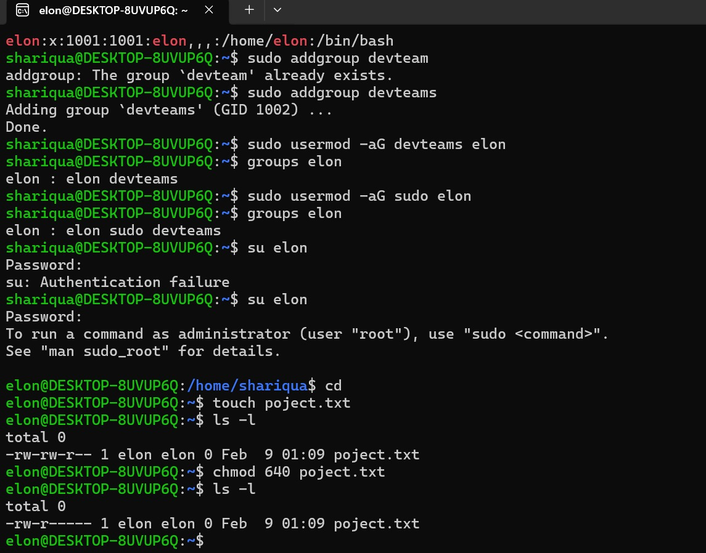

Conclusion:
This task provided hands-on experience with Linux user, group, and permission management.

Author:
Shariqua Patel Farooque

